#include<stdio.h>

#include<stdlib.h>

#include<string.h>

void pprint(){

printf("(1)建立員工檔案\n");

printf("(2)新增員工檔案\n");

printf("(3)查詢員工檔案\n");

printf("(4)刪除員工檔案\n");

printf("(5)顯示報表\n");

printf("(6)按薪水由少到多排序\n");

printf("(7)結束\n");

}

struct staff{

char name[10];

int age;

int salary;

struct staff \*next;

};

int main(){

printf("(1)建立員工檔案\n");

printf("(7)結束\n");

int choose;

bool first=false;

struct staff \*begin=((struct staff\*)malloc(sizeof(struct staff)));

struct staff \*ptr=((struct staff\*)malloc(sizeof(struct staff)));

struct staff \*pt=((struct staff\*)malloc(sizeof(struct staff)));

first=true;

char cc;

while(true){

scanf("%d",&choose);

if(choose==1){//建立

system("CLS");

struct staff \*in=((struct staff\*)malloc(sizeof(struct staff)));

char nname[10];

if(first==true){

printf("名字:");

scanf("%s",&nname);

strcpy(in->name,nname);

printf("年齡:");

scanf("%d",&in->age);

printf("薪水:");

scanf("%d",&in->salary);

in->next=NULL;

ptr=in;

begin=ptr;

first=false;

printf("q結束，其他任一鍵繼續: ");

scanf(" %c",&cc);

}

else{

printf("名字:");

scanf("%s",&nname);

strcpy(in->name,nname);

printf("年齡:");

scanf("%d",&in->age);

printf("薪水:");

scanf("%d",&in->salary);

in->next=NULL;

ptr->next=in;

ptr=ptr->next;

printf("q結束，其他任一鍵繼續: ");

scanf(" %c",&cc);

}

while(cc!='q'){

struct staff \*iin=((struct staff\*)malloc(sizeof(struct staff)));

printf("名字:");

scanf("%s",&nname);

strcpy(iin->name,nname);

printf("年齡:");

scanf("%d",&iin->age);

printf("薪水:");

scanf("%d",&iin->salary);

printf("%s %d %d\n",iin->name,iin->age,iin->salary);

iin->next=NULL;

ptr->next=iin;

ptr=ptr->next;

printf("q結束，其他任一鍵繼續: ");

scanf(" %c",&cc);

}

system("CLS");

pprint();

}

else if(choose==2 && first==false){//新增

system("CLS");

struct staff \*in=((struct staff\*)malloc(sizeof(struct staff)));

char nname[10];

printf("名字:");

scanf("%s",&nname);

strcpy(in->name,nname);

printf("年齡:");

scanf("%d",&in->age);

printf("薪水:");

scanf("%d",&in->salary);

in->next=NULL;

ptr->next=in;

ptr=ptr->next;

system("CLS");

pprint();

}

else if(choose==3 && first==false){//查詢

system("CLS");

printf("輸入的員工名字:");

char nname[10];

scanf(" %s",&nname);

pt=begin;

while(pt!=NULL){

char nn[10];

strcpy(nn,pt->name);

if(strcmp(nname,nn)!=0){

pt=pt->next;

}

else{

printf("年齡:%d\n",pt->age);

printf("薪水:%d\n",pt->salary);system("pause");

break;

}

}

system("CLS");

pprint();

}

else if(choose==4 && first==false){//刪除

system("CLS");

printf("輸入員工名字:\n");

char nname[10];

scanf("%s",&nname);

pt=begin->next;

struct staff \*ptbefore=((struct staff\*)malloc(sizeof(struct staff))); ptbefore=begin;

while(pt!=NULL){

if(strcmp(nname,begin->name)==0){

begin=begin->next;

break;

}

else if(strcmp(nname,pt->name)==0){

ptbefore->next=pt->next;

break;

}

else{

ptbefore=pt;

pt=pt->next;

}

}

system("CLS");

pprint();

}

else if(choose==5 && first==false){//顯示

system("CLS");

pt=begin;

while(pt!=NULL){

printf("名字:%s\n",pt->name);

printf("年齡:%d\n",pt->age);

printf("薪水:%d\n",pt->salary);

printf("-------------\n");

pt=pt->next;

}

system("pause");

system("CLS");

pprint();

}

else if(choose==6 && first==false){//排序

system("CLS");

struct staff \*tail=((struct staff\*)malloc(sizeof(struct staff)));

struct staff \*tmp=((struct staff\*)malloc(sizeof(struct staff)));

struct staff \*cur=((struct staff\*)malloc(sizeof(struct staff)));

struct staff \*pre=((struct staff\*)malloc(sizeof(struct staff)));

tail=begin;

tmp=begin;

cur=begin;

pre=begin;

int size=0;

while(tail!=NULL){

tail=tail->next;

size++;

}

for(int i=size;i>0;i--){

cur=begin;

pre=begin;

for(int j=0;j<i-1 && cur->next ;j++){

if(cur->salary>cur->next->salary){

tmp=cur->next;

cur->next=tmp->next;

tmp->next=cur;

if(cur==begin){

begin=tmp;

pre=tmp;

}

else{

pre->next=tmp;

pre=pre->next;

}

}

else{

cur=cur->next;

if(j!=0){

pre=pre->next;

}

}

}

}

pt=begin;

while(pt!=NULL){

printf("名字:%s\n",pt->name);

printf("年齡:%d\n",pt->age);

printf("薪水:%d\n",pt->salary);

printf("-------------\n");

pt=pt->next;

}

system("pause");

system("CLS");

pprint();

}

else if(choose==7){//結束

break;

}

else if((choose==2||choose==3||choose==4||choose==5||choose==6) && first==true){

printf("未有資料輸入，請輸入1(輸入資料)或7(離開)\n");

system("pause");

system("CLS");

printf("(1)建立員工檔案\n");

printf("(7)結束\n");

}

else if(choose!=1||choose!=2||choose!=3||choose!=4||choose!=5||choose!=6||choose!=7){

printf("請輸入1~7\n");

system("pause");

system("CLS");

pprint();

}

}

system("pause");

return 0;

}

輸入1 輸入檔案(多個)

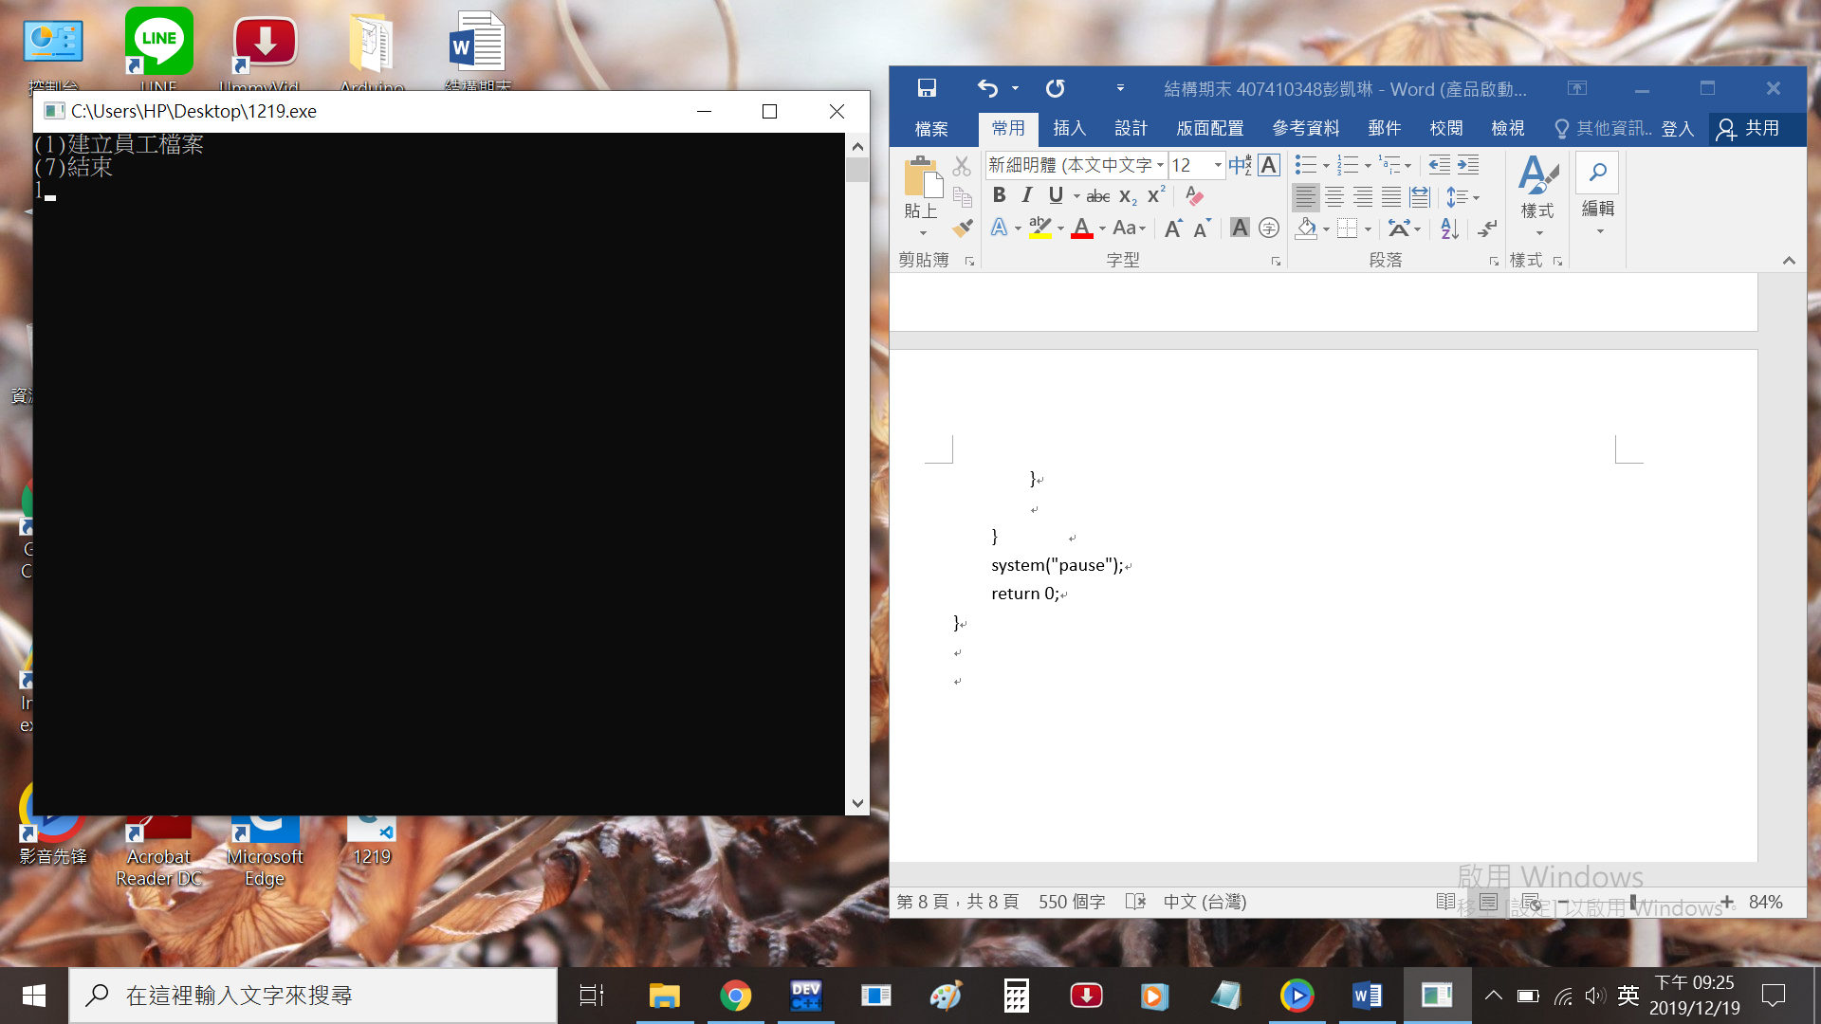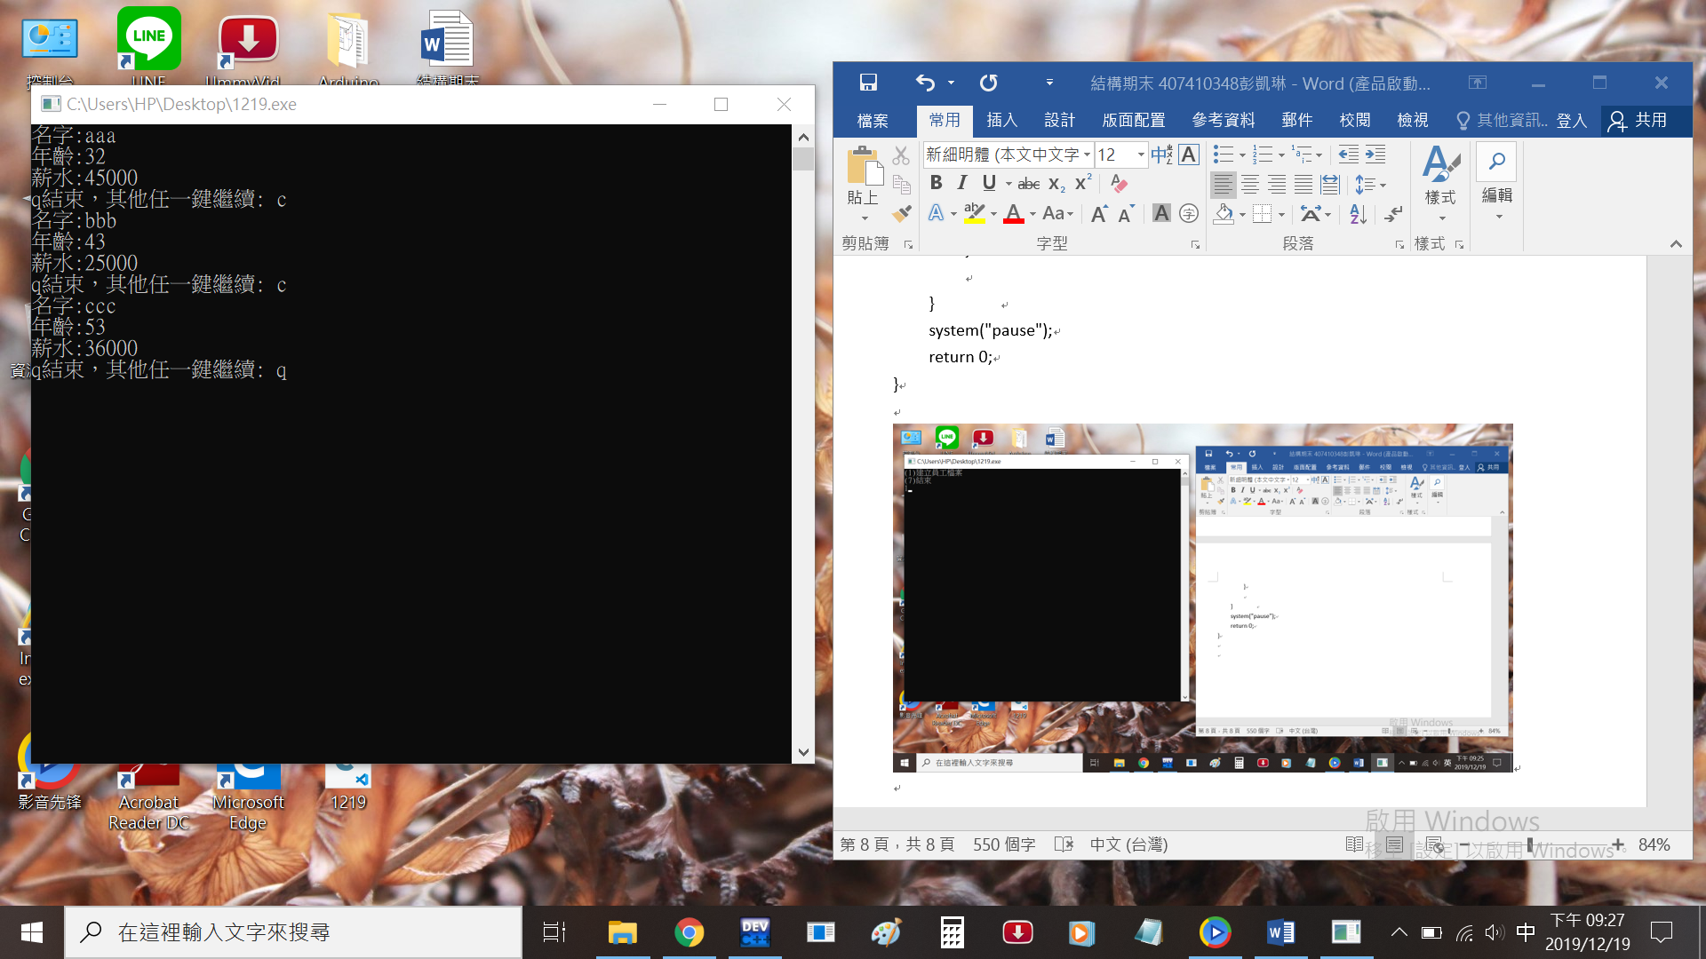

跳回項目表 選項5 顯示

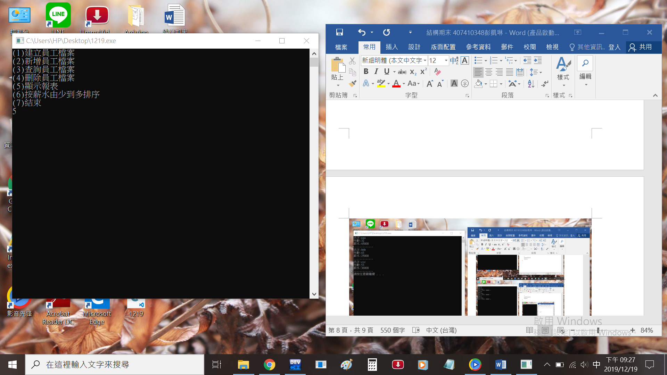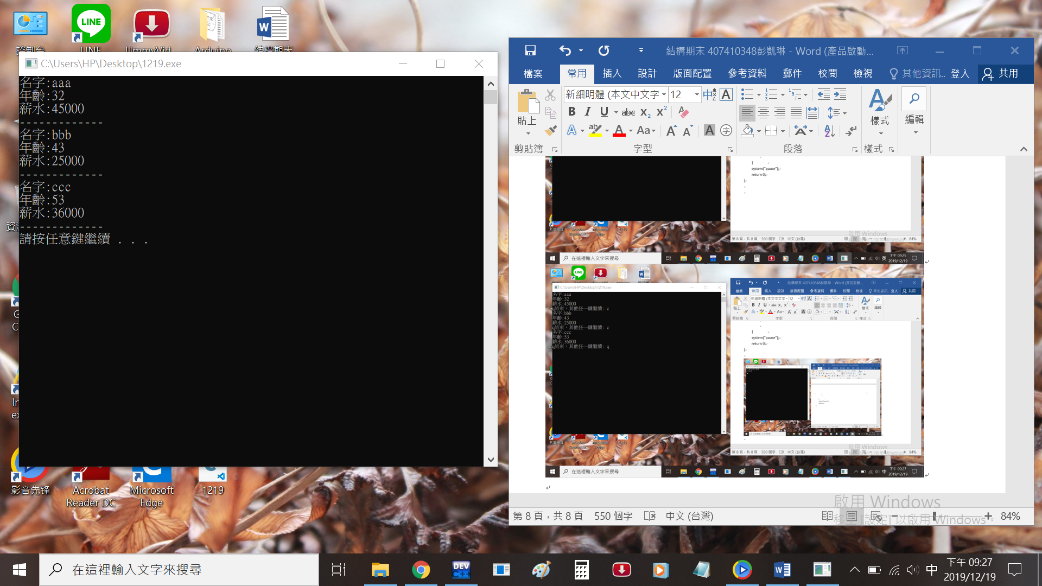

輸入2 增加檔案(1個)

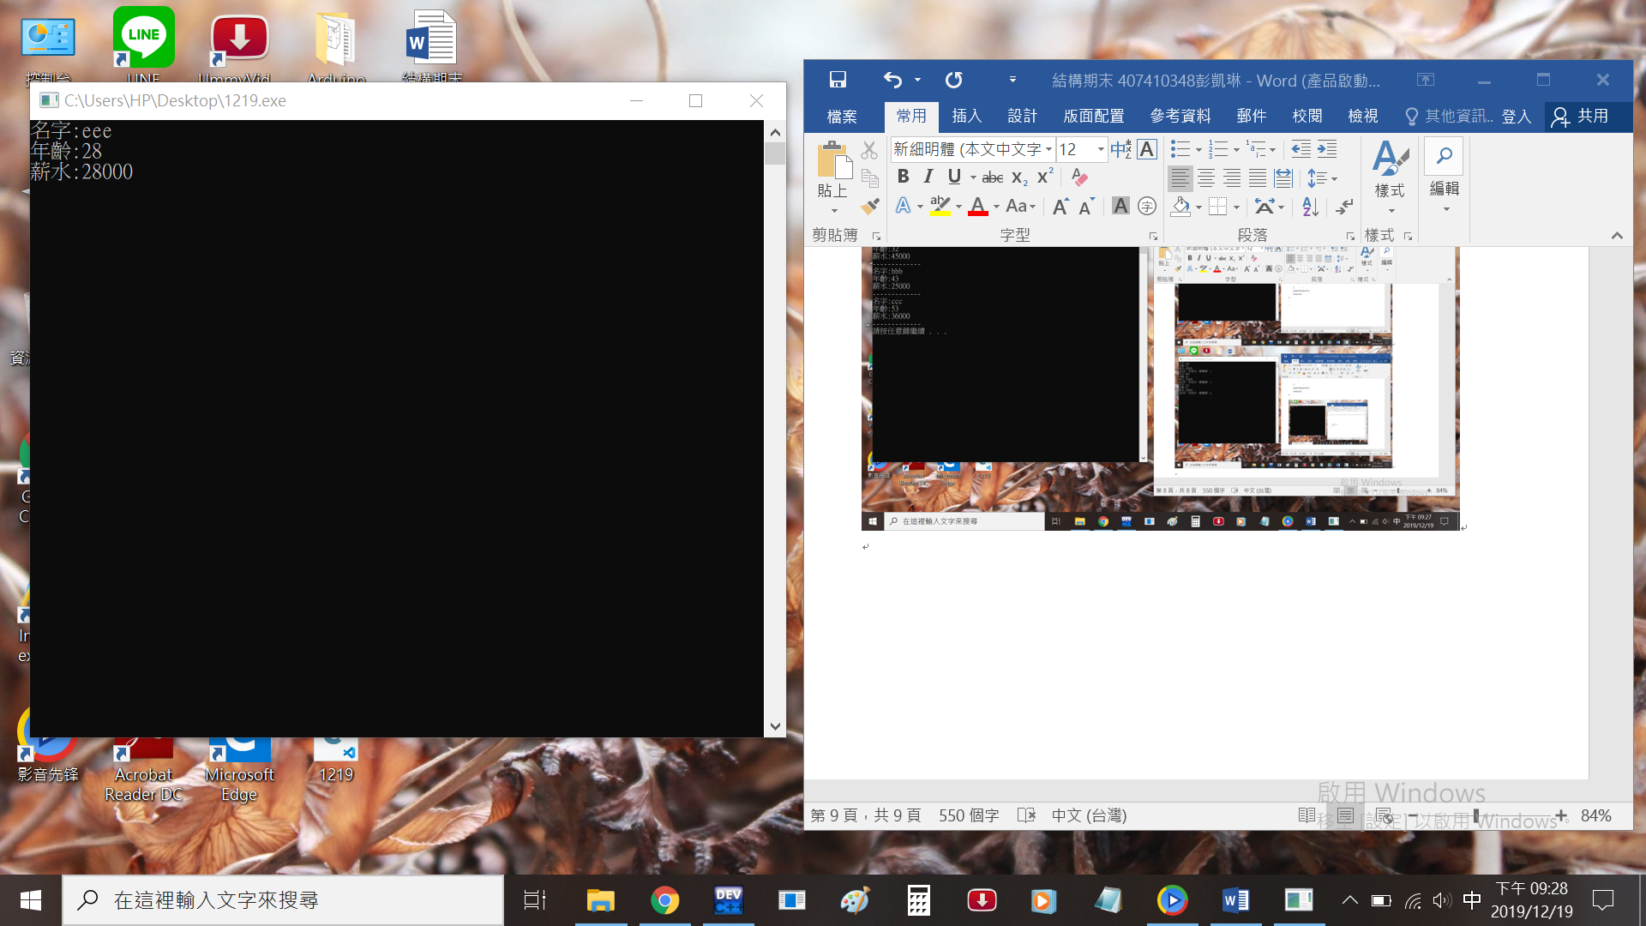

跳回項目表 選項5 顯示

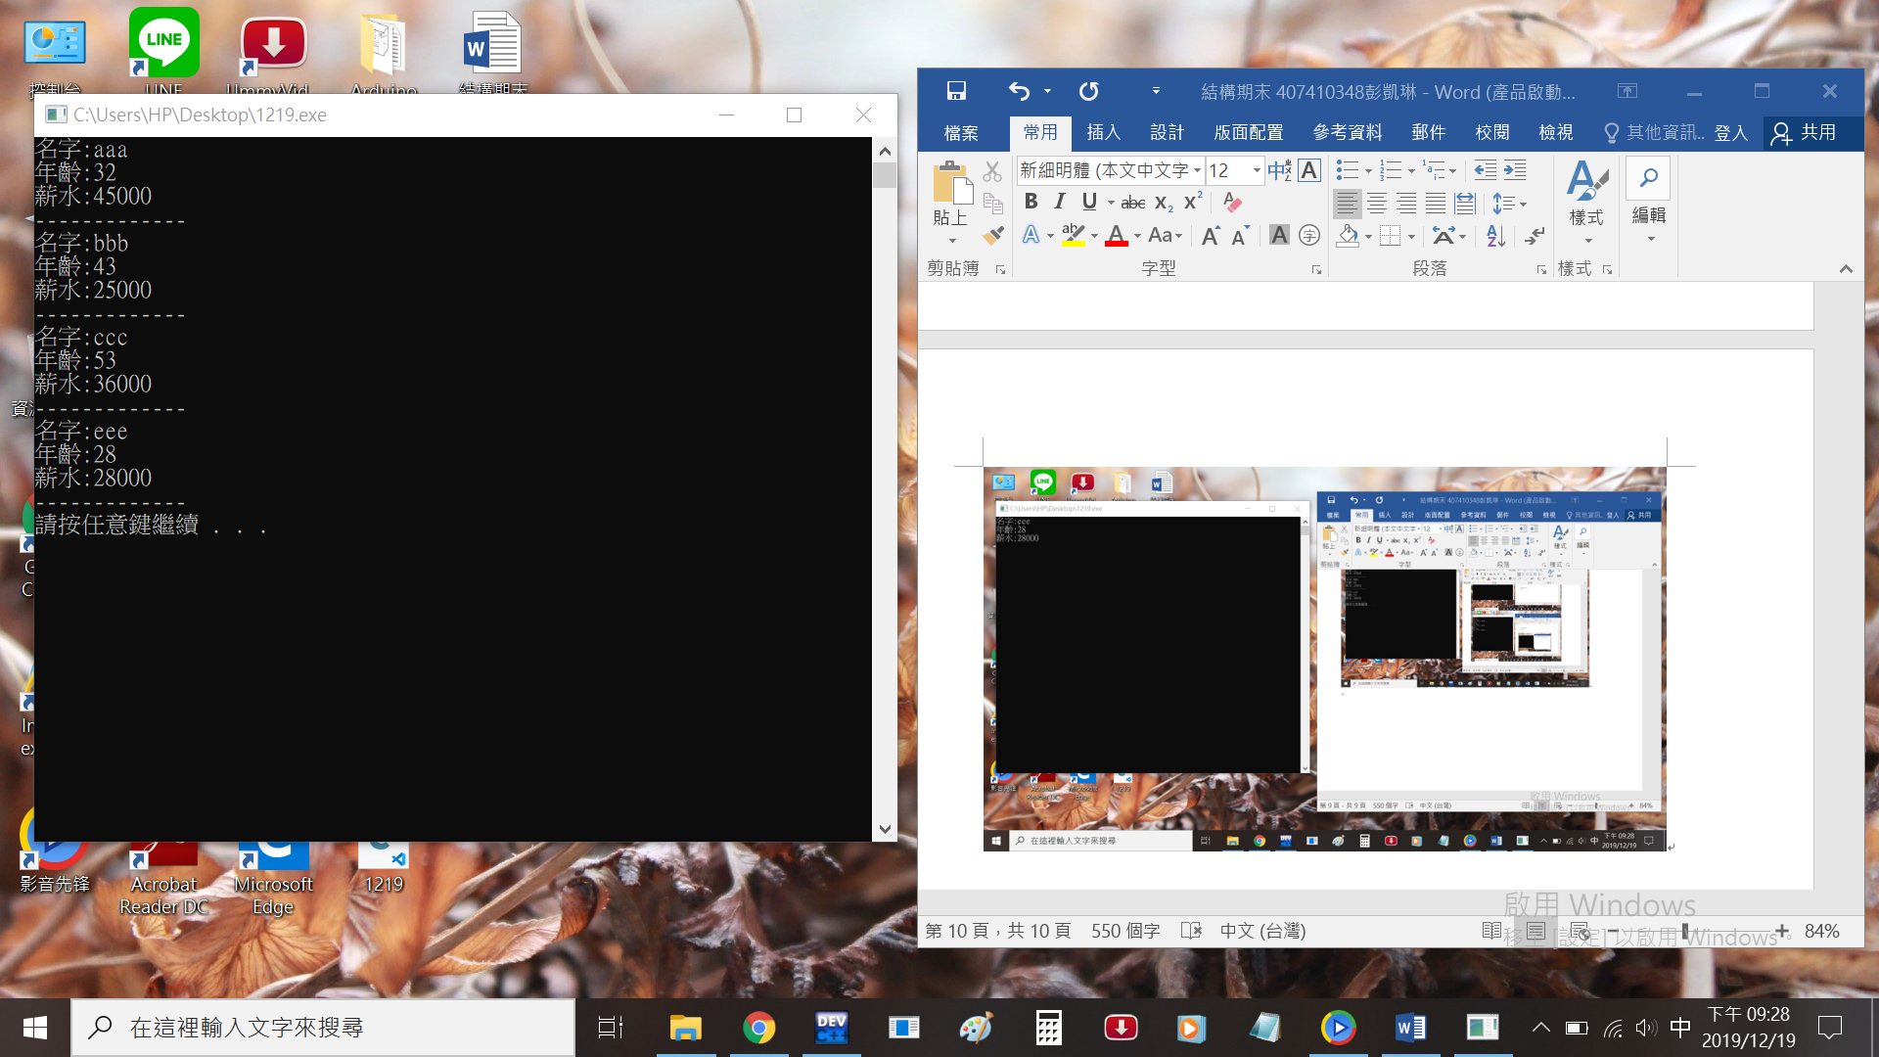

輸入3 查詢檔案

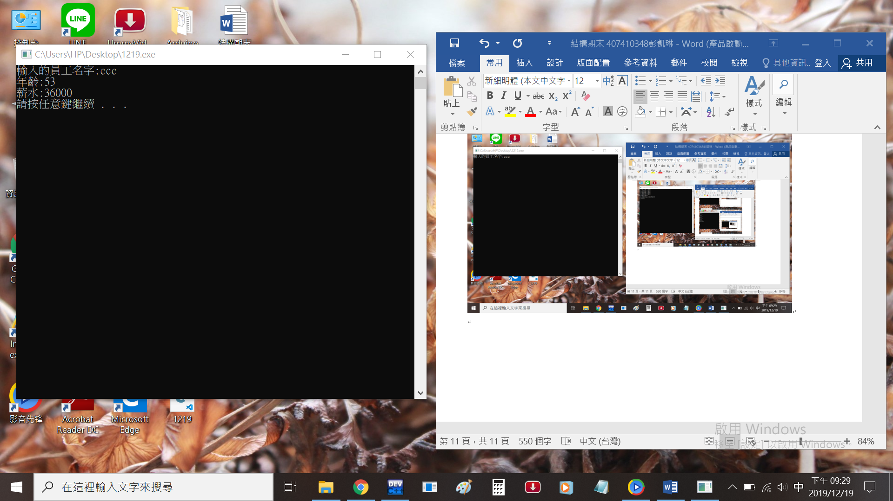

輸入4 刪除檔案

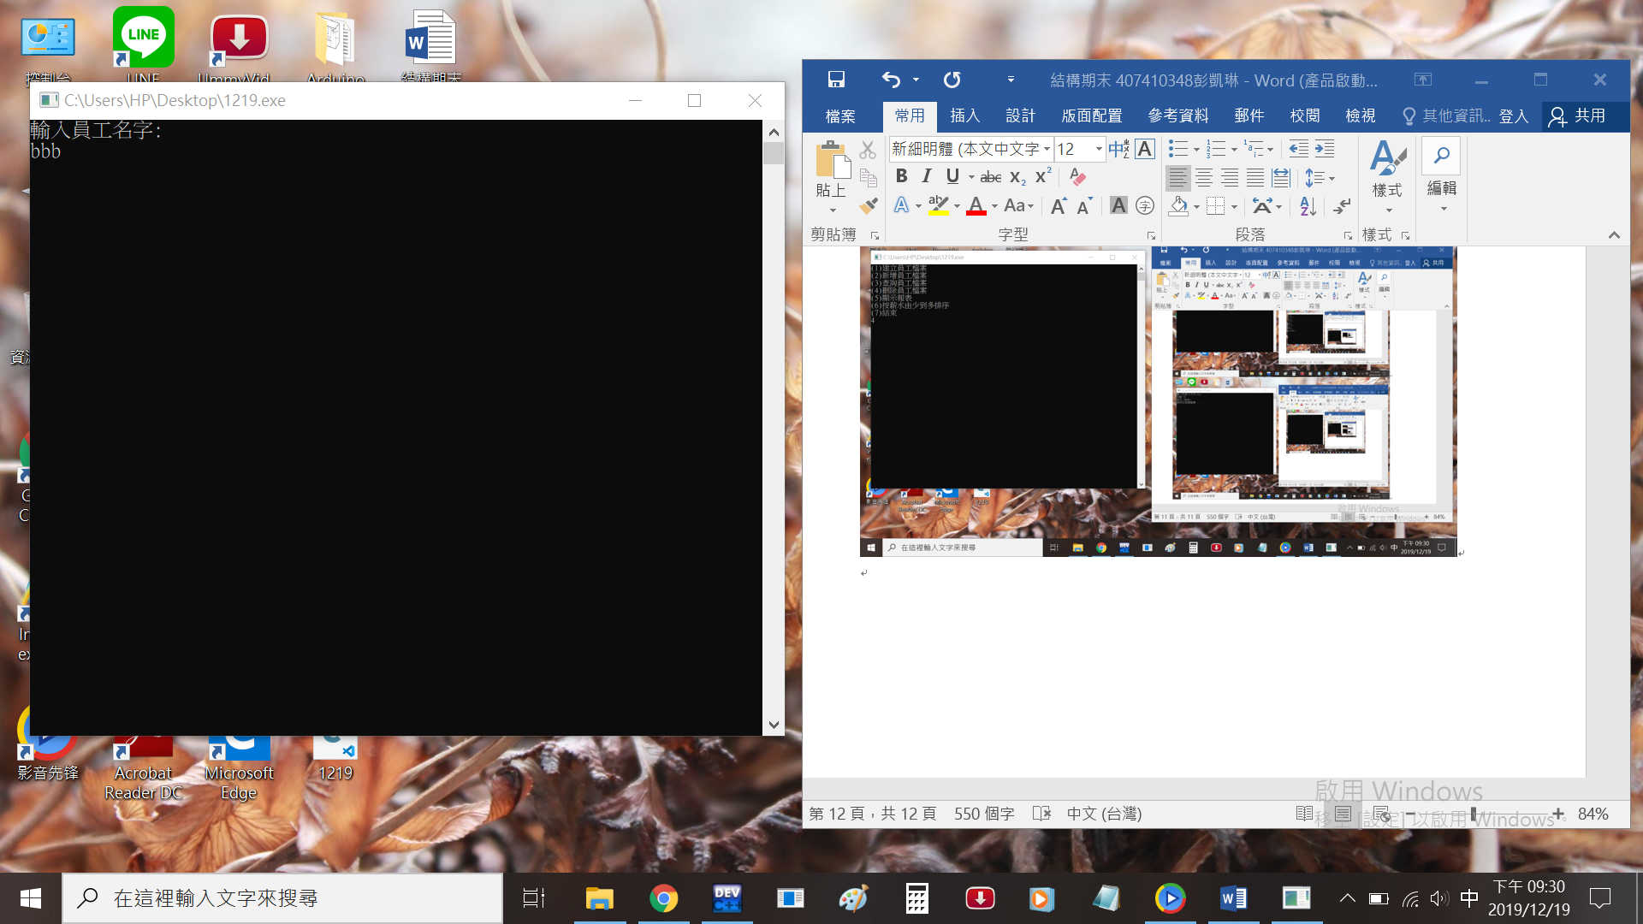

跳回項目表 選項5 顯示

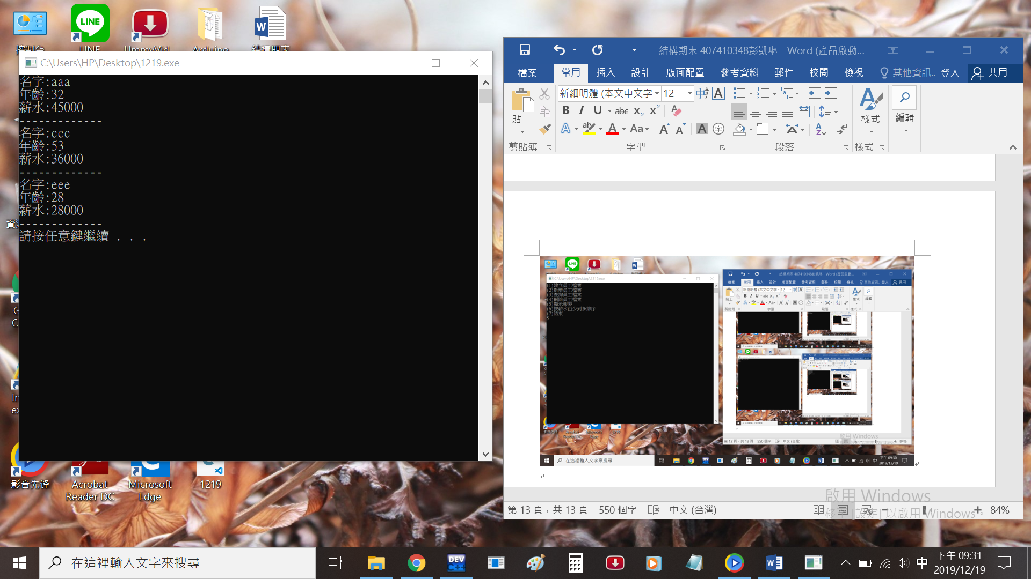

輸入6 按薪水排序

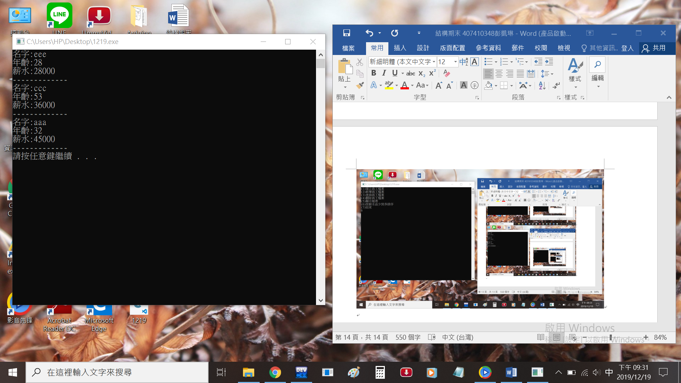

輸入7 結束

